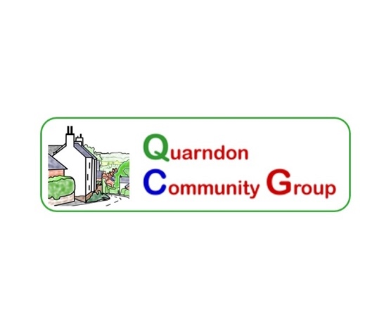**Quarndon Contacts**

<https://www.quarndon-pc.gov.uk/community1.html>

[www.quarndon-pc.gov.uk](http://www.quarndon-pc.gov.uk/)

* **Quarndon Parish Council**
  + Contact: Clerk at [clerk@quarndon-pc.gov.uk](mailto:clerk@quarndon-pc.gov.uk)
  + Website: <https://www.quarndon-pc.gov.uk/>
* **Quarndon Community Group**
  + Contact: [qcg@quarndon-village.org.uk](mailto:qcg@quarndon-village.org.uk)
* **Quarndon Events:** quizzes, film nights, talks and more
  + <https://www.quarndon-pc.gov.uk/quarndon-events.html>
  + E-mail: [Quarndonevents@gmail.com](mailto:Quarndonevents@gmail.com)
* **Quarndon Footpaths**
  + <https://www.quarndon-pc.gov.uk/walking-around-quarndon.html>
* **Quarndon walking group**
  + Contact Martin Cross: [drmtcross@btinternet.com](mailto:drmtcross@btinternet.com)

****************************************

* **Allestree Park**
  + Information: [parks@derby.gov.uk](mailto:parks@derby.gov.uk)
  + <https://www.friendsofallestreepark.org.uk/>
* **Community Gardens:** volunteers very welcome
  + Contact: [rosgrum@gmail.com](mailto:rosgrum@gmail.com)
* **Community Speedwatch:** Volunteers welcome; to find out more or join Speedwatch contact [isobeljshorrock@gmail.com](http://isobeljshorrock@gmail.com)
* **Cricket Club**, the Common
  + <https://quarndon.play-cricket.com/home>
* **Curzon Cof E Primary School**
  + Contact: [info@curzon.derbyshire.sch.uk](mailto:info@curzon.derbyshire.sch.uk)
  + <https://quarndonquads.co.uk/>
* **GP Practices**
  + Park Farm Medical Centre: 01332 559402
    - <https://www.parkfarm-medical.co.uk/>
  + Appletree Medical Practice Duffield: 01332 842288
    - <https://appletreemedical.co.uk/>
  + Park Lane Surgery: 01332 552461 <https://www.parklanesurgeryallestree.co.uk>
* **Joiners Arms, Church Road** To book a table: <https://theja.co.uk/book-a-table>
* **Kedleston Country House Hotel,** Kedleston Road. To book a table visit [https://www.kedlestoncountryhouse.co.uk](https://www.kedlestoncountryhouse.co.uk/)
* **Neighbourhood Plan**
  + <https://www.quarndon-pc.gov.uk/neighbourhood-plan.html>
* **Neighbourhood Watch**
  + Contact: [pricegerald3@aol.com](mailto:pricegerald3@aol.com)
* **Phone Box Book Exchange**
  + Borrow and donate books from the phone box next to the village hall
* **Play area at Barn Close, Quarndon**
  + Barn Close Recreation Ground is open for visitors to use the Trim Trail and play equipment, and enjoy relaxing at the picnic tables. Well-behaved dogs are welcome. See the entrance sign or contact [clerk@quarndon-pc.gov.uk](mailto:clerk@quarndon-pc.gov.uk) for more information.
* **Pre-School, Village Hall**
  + Contact: 01332 556611
  + <https://quarndonpreschool.org/>
* **Quarndon amateur dramatics group (QUADS)** Contact <https://quarndonquads.co.uk/>
* **Quarndon Swift Group** Contact John Farnsworth at [jpfarnsworth4@gmail.com](http://jpfarnsworth4@gmail.com)
* **Repair café:** last Saturday every month, Village Hall. Volunteers always welcome. Contact: [quarndonrepaircafe@gmail.com](mailto:quarndonrepaircafe@gmail.com)
* **St Paul’s C of E Church**
  + <https://www.achurchnearyou.com/church/13381/>
* **Table Tennis Group:** Wednesdays 11:30-12:30 in the Village Hall. Contact Liz Harris on 07960 824293 or at [bryanlizharris@btinternet.com](mailto:bryanlizharris@btinternet.com)
* **Vets**
  + Scarsdale Vets Park farm: 01332 554422
    - <https://www.scarsdalevets.com/practice/park-farm>
  + St Leonard Vet Centre Allestree: 01332 553396
    - <https://www.slvets.co.uk/locations-contact/>
* **Village Hall**
  + Classes and events: https://www.quarndon-pc.gov.uk/local-events
  + Bookings: <https://www.achurchnearyou.com/church/13381/page/79234/view/>
    - Tel: 07973 702002